January 30, 2020

To whom it may concern,

On behalf of the Auburn University Intercollegiate Horse Show Association Team (IHSA), we would like to extend an invitation to you and your company to consider being a sponsor for our team this coming upcoming 2020 show season. We realize that without corporate and individual sponsorship, the successes our program has achieved would not be possible. Additionally, given the outstanding reputation of our program across the nation and amongst other rivaled institutions, we believe that your involvement in our program has profound and lasting effects on the members of the Auburn IHSA Team.
The IHSA is an all-inclusive organization that welcomes the most novice riders up to and including those individuals with more advanced skills in horsemanship in both the hunter and western disciplines of riding competition. Each member is provided the opportunity to compete individually and as a team. Our organization was founded on the principles that any college student that expresses a desire and love for horses can have the opportunity to participate in equestrian competition regardless of their financial status, gender, or riding skill level. IHSA promotes continual education of sportsmanship and fostering teamwork. IHSA also eliminates the expenses of horse ownership through the host colleges, thus allowing more students the opportunity to participate. Each student that is a member of IHSA is a full-time undergraduate student of their respective college or an alumni who previously competed with IHSA during their undergraduate career. Riders are also able to qualify for the National Championship Horse Show through a tiered point system, accumulating points at their respective local regional shows.
On behalf of the Auburn IHSA, thank you in advance for taking the time to invest in reading this and for considering becoming a sponsor and an integral part of our upcoming 2019- 2020 season. It is through your generous contributions that the Auburn IHSA is able to provide more students the opportunity to participate in a team sport at a more affordable cost. As part of this invitation, we have attached an AU IHSA Sponsor Registration Form and a Sponsorship Informational Packet. All donations are greatly appreciated, and none are too small. Signing up has never been made more simple, just complete the form on the last page of this packet and submit it at your earliest convenience. We sincerely hope that you will consider joining us to enhance the success of the Auburn IHSA Equestrian Team.
If you have any questions or concerns, please contact Claire Cranford at cmr0057@auburn.edu.

War Eagle!
Claire Cranford
AU IHSA 2019-2020 Treasurer

*Any and ALL donations are welcome. If we do not have the desired amount you or your company would like to donate listed, please let us know.

Auburn Equestrian
IHSA Sponsorship Packet
2021-22

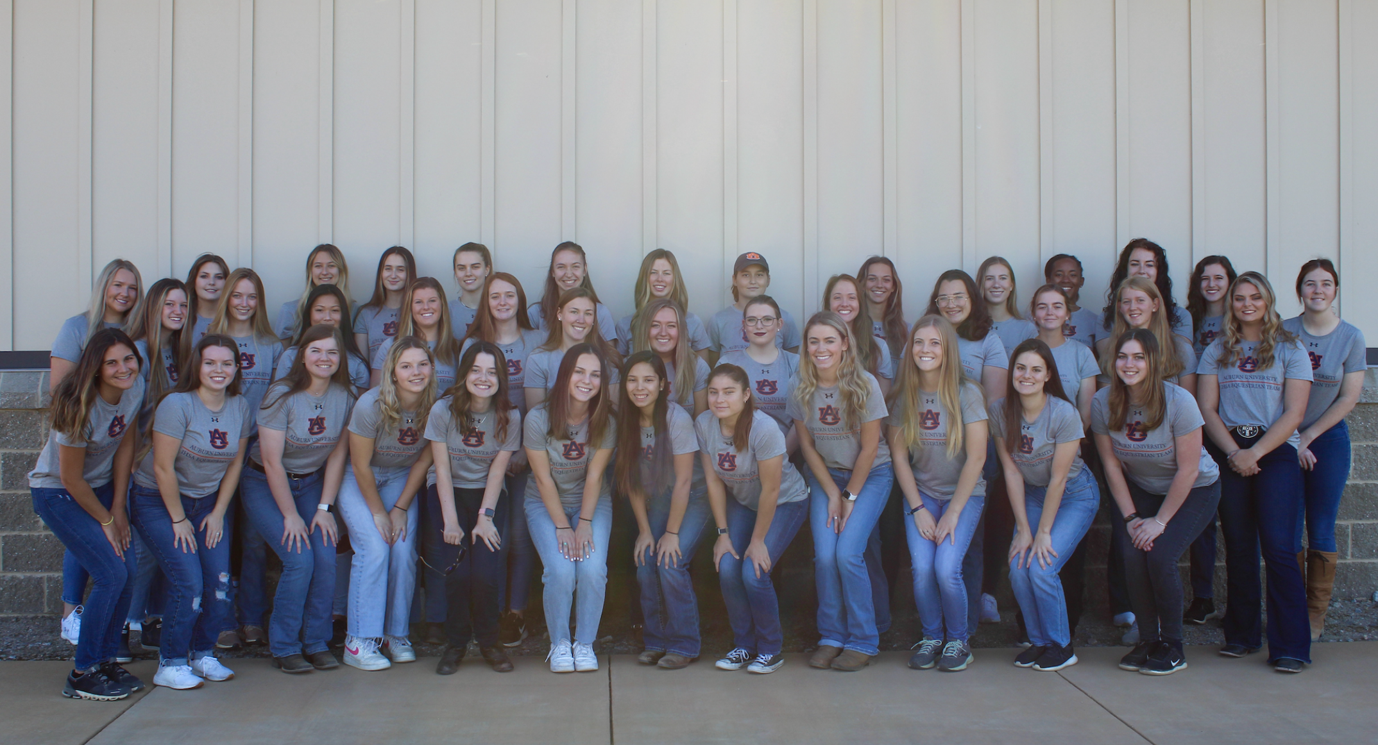

Platinum Sponsors | Gold Sponsors | Silver Sponsors | Bronze Sponsors
Platinum Sponsors are those who contribute $5,000 or more, or its equivalent in product  Platinum Sponsors will receive the following*:  - Inclusion in all press events  - Name recognition on the Facebook page as a special feature in the biography  - Social media coverage on all recognized media avenues, as well as three mentions per week by AU IHSA competing members  - Link to company page from website  - Recognition at opening ceremonies of all AU home shows  - Name and/or logo on event schedules, score sheets  - Two full page color advertisements within the event programs at AU home shows  - Three sponsor signs in high traffic areas around Auburn, AL (locations chosen by members of the AU IHSA team)  - Five event programs from every AU home show  - Five product and sponsorship announcements per division (Western and Hunt Seat) per day | Gold Sponsors are those who contribute $3,500 or more, or its equivalent in product  Gold Sponsors will receive the following*:  - Name recognition on the Facebook page as a special feature in the biography  - Social media coverage once every other day on all recognized media avenues, as well as mentions once per week by AU IHSA competing members  - Link to company page from website  - Recognition at opening ceremonies of all AU home shows  - One full page color advertisement within the event programs at AU home shows  - One sponsor sign in high traffic areas around Auburn, AL (locations chosen by the board members of the AU IHSA team)  - Four event programs  - Two product and sponsorship announcements per division (Western and Hunt Seat) per day. | Silver Sponsors are those who contribute $2,500 or more, or its equivalent in product  Silver Sponsors will receive the following*:  - Name recognition on the Facebook page as a special feature in the biography  - Social media coverage twice a week on all recognized media avenues, as well as mentions once every two weeks by AU IHSA competing members  - Link to company page from website  - Recognition at opening ceremonies of all AU home shows  - One half-page color advertisement within the event programs at AU home shows  - Three event programs  - One product and sponsorship announcement per division (Western and Hunt Seat) per day. | Bronze Sponsors are those who contribute $1,000 or more, or its equivalent in product  Bronze Sponsors will receive the following*:  - Name recognition on the Facebook page as a special feature in the biography  - Social media coverage once a week on all recognized media avenues, as well as one mention a month by AU IHSA competing members  - Link to company page from website  - Recognition at all opening ceremonies of all AU home shows  - Two event programs  - One product and sponsorship announcement per day.
Rider Sponsors | Horse Sponsors | Show Sponsors | Open Sponsors
Rider Sponsors are those who agree to contribute at least $2000 each year to cover show expenses for AU riders throughout the season. This contribution will go towards, vans, buses, hotels, team meals and entry fees.  Rider Sponsors will receive the following*:  - Monthly updates from the riders  - Pictures of the team during away meets  - Statistics regarding the performance of the Riders  - Name recognition on the Facebook page as a specific feature (subset feature) of the biography  - Two event programs from home competitions  - Recognition at all AU home shows as a private sponsor | Horse Sponsors are those who agree to contribute approx. $1,500 each semester for general maintenance and care of team horses  Horse Sponsors will receive the following*:  - Monthly updates regarding the sponsored horse  - Pictures of the sponsored horse during meets and practices (when applicable)  - Statistics regarding the performance of the horse  - Name recognition on the Facebook page as a specific feature (subset feature) on the biography  - Two event programs  - Recognition at all AU home shows as a private sponsor | Show Sponsors are those who agree to contribute approx. $500 each year towards awards, judges, and provisions for home shows  Show Sponsors will receive the following*:  - Monthly updates regarding the team  - Pictures of the horses on the facility and practices (when applicable)  - General statistics regarding the performance of the AU IHSA Equestrian team  - Name recognition on the Facebook page  - Two event programs  - Recognition at all AU home shows as a private sponsor | Open Sponsors are those who have contributed at least $250 of product or money to the AU IHSA team for purposes the sponsor sees fit  Open Sponsors will receive the following*:  - Monthly updates regarding the team  - General statistics regarding the performance of the AU IHSA Equestrian team  - Name recognition on the Facebook page in a specific feature (subset feature) on the biography  - Two event programs  - Recognition at all AU home shows a private Sponsor
*All sponsor benefits are subject to change according to the agreement made with the sponsor party and the AU IHSA Executive Board.
Auburn IHSA Equestrian Team Sponsor Information:
Please fill out the following information and return with donations.

Full Name: __________________________________________________________________

E-mail: _____________________________________________________________________

Phone Number: _____________________________________________________________

Current Address: _____________________________________________________________

Preferred update method, if choosing a sponsorship level that provides updates.
(circle one): E-mail Mail

Sponsorship Level: ____________________________________________________________

-or-

Desired amount to donate ($ value): _______________________________________________

*Please make all checks payable to: Auburn Equestrian Club

**Please mail all checks to: Auburn University Equestrian Center
ATTN: Lisa Dorsey
651 Heisman Dr
Auburn, AL 36849

***Please include this sponsor information sheet with mailed check

